SOFTWARE TESTING METHODOLO HW 4

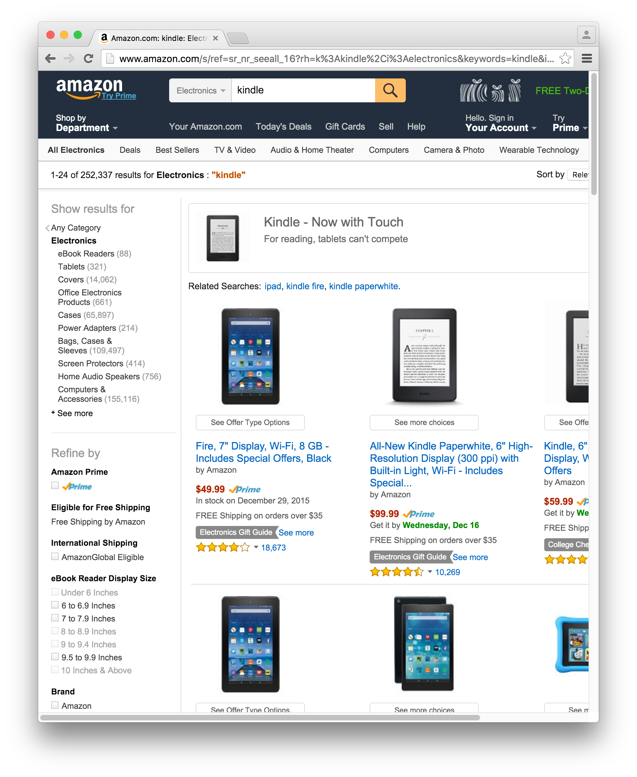Explore the webdriver to do some test on amazon, search kindle fire HD in search text bar, and see the results do some test.

The test included:

1. Is this is amazon website?

2. if kindle in this search result?

3. if kindle Fire HD item in serach result?

4. if kindle Fire HD price is below 40.00 dollars

